**CUSTOMER CARE REGISTRY**



**SOLUTION ARCHITECTURE**

# TEAM DETAILS:



**Team No :** PNT2022TMID26814

**College Name :** Dhanalakshmi Srinivasan College of Engineering & Technology

**Department :** Computer Science & Engineering

# PROBLEM MEMBERS:

* SHARMILA D
* SEVVANTHI D
* SHOBANA M
* THATCHAYANI I
* NAVIN KUMAR

Solution Architecture 2

# PROJECT DESIGN PHASE –I

ARCHITECTURE

|  |  |
| --- | --- |
| **DATE** | **01.10.2022** |
| **TEAM ID** | PNT2022TMID26814 |
| **PROJECT NAME** | CUSTOMER CARE REGISTRY |
| **MAXIMUM MARKS** | -------- |

Solution Architecture 3

# PROJECT DESIGN PHASE –I

ARCHITECTURE

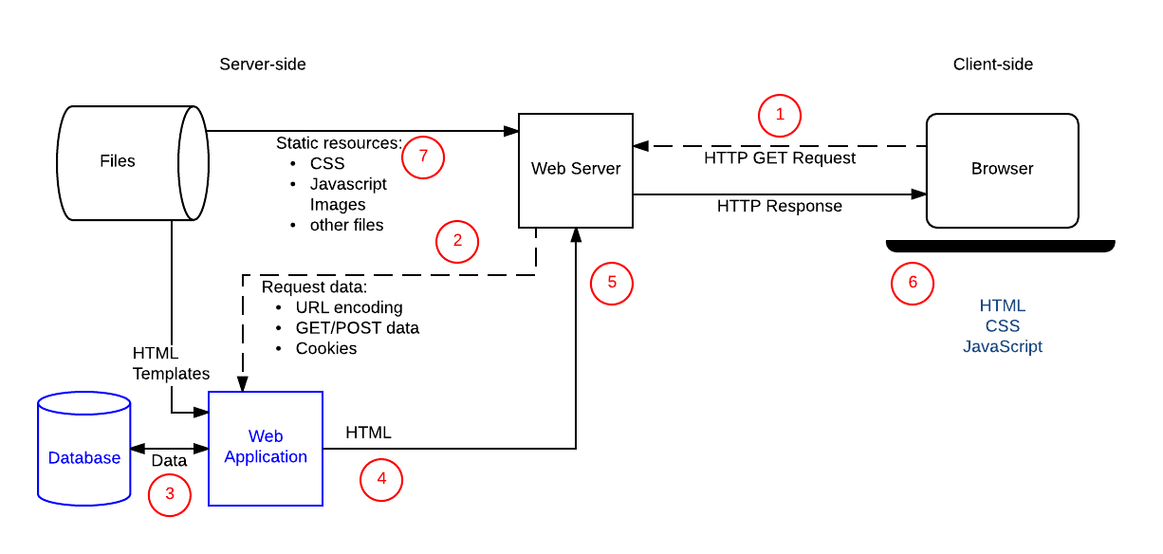

Solution Architecture 4

TECHNICAL ARCHITECTURE

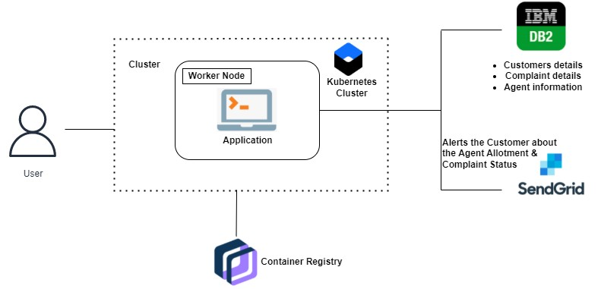

Solution Architecture 5



**Thank you**